CAKE & BAKERY
Sweet
Craft
Sneha gawade

Jane Doe
Branch Manager
9420710443
 Amboli Faujdarwadi
@snehagadade159

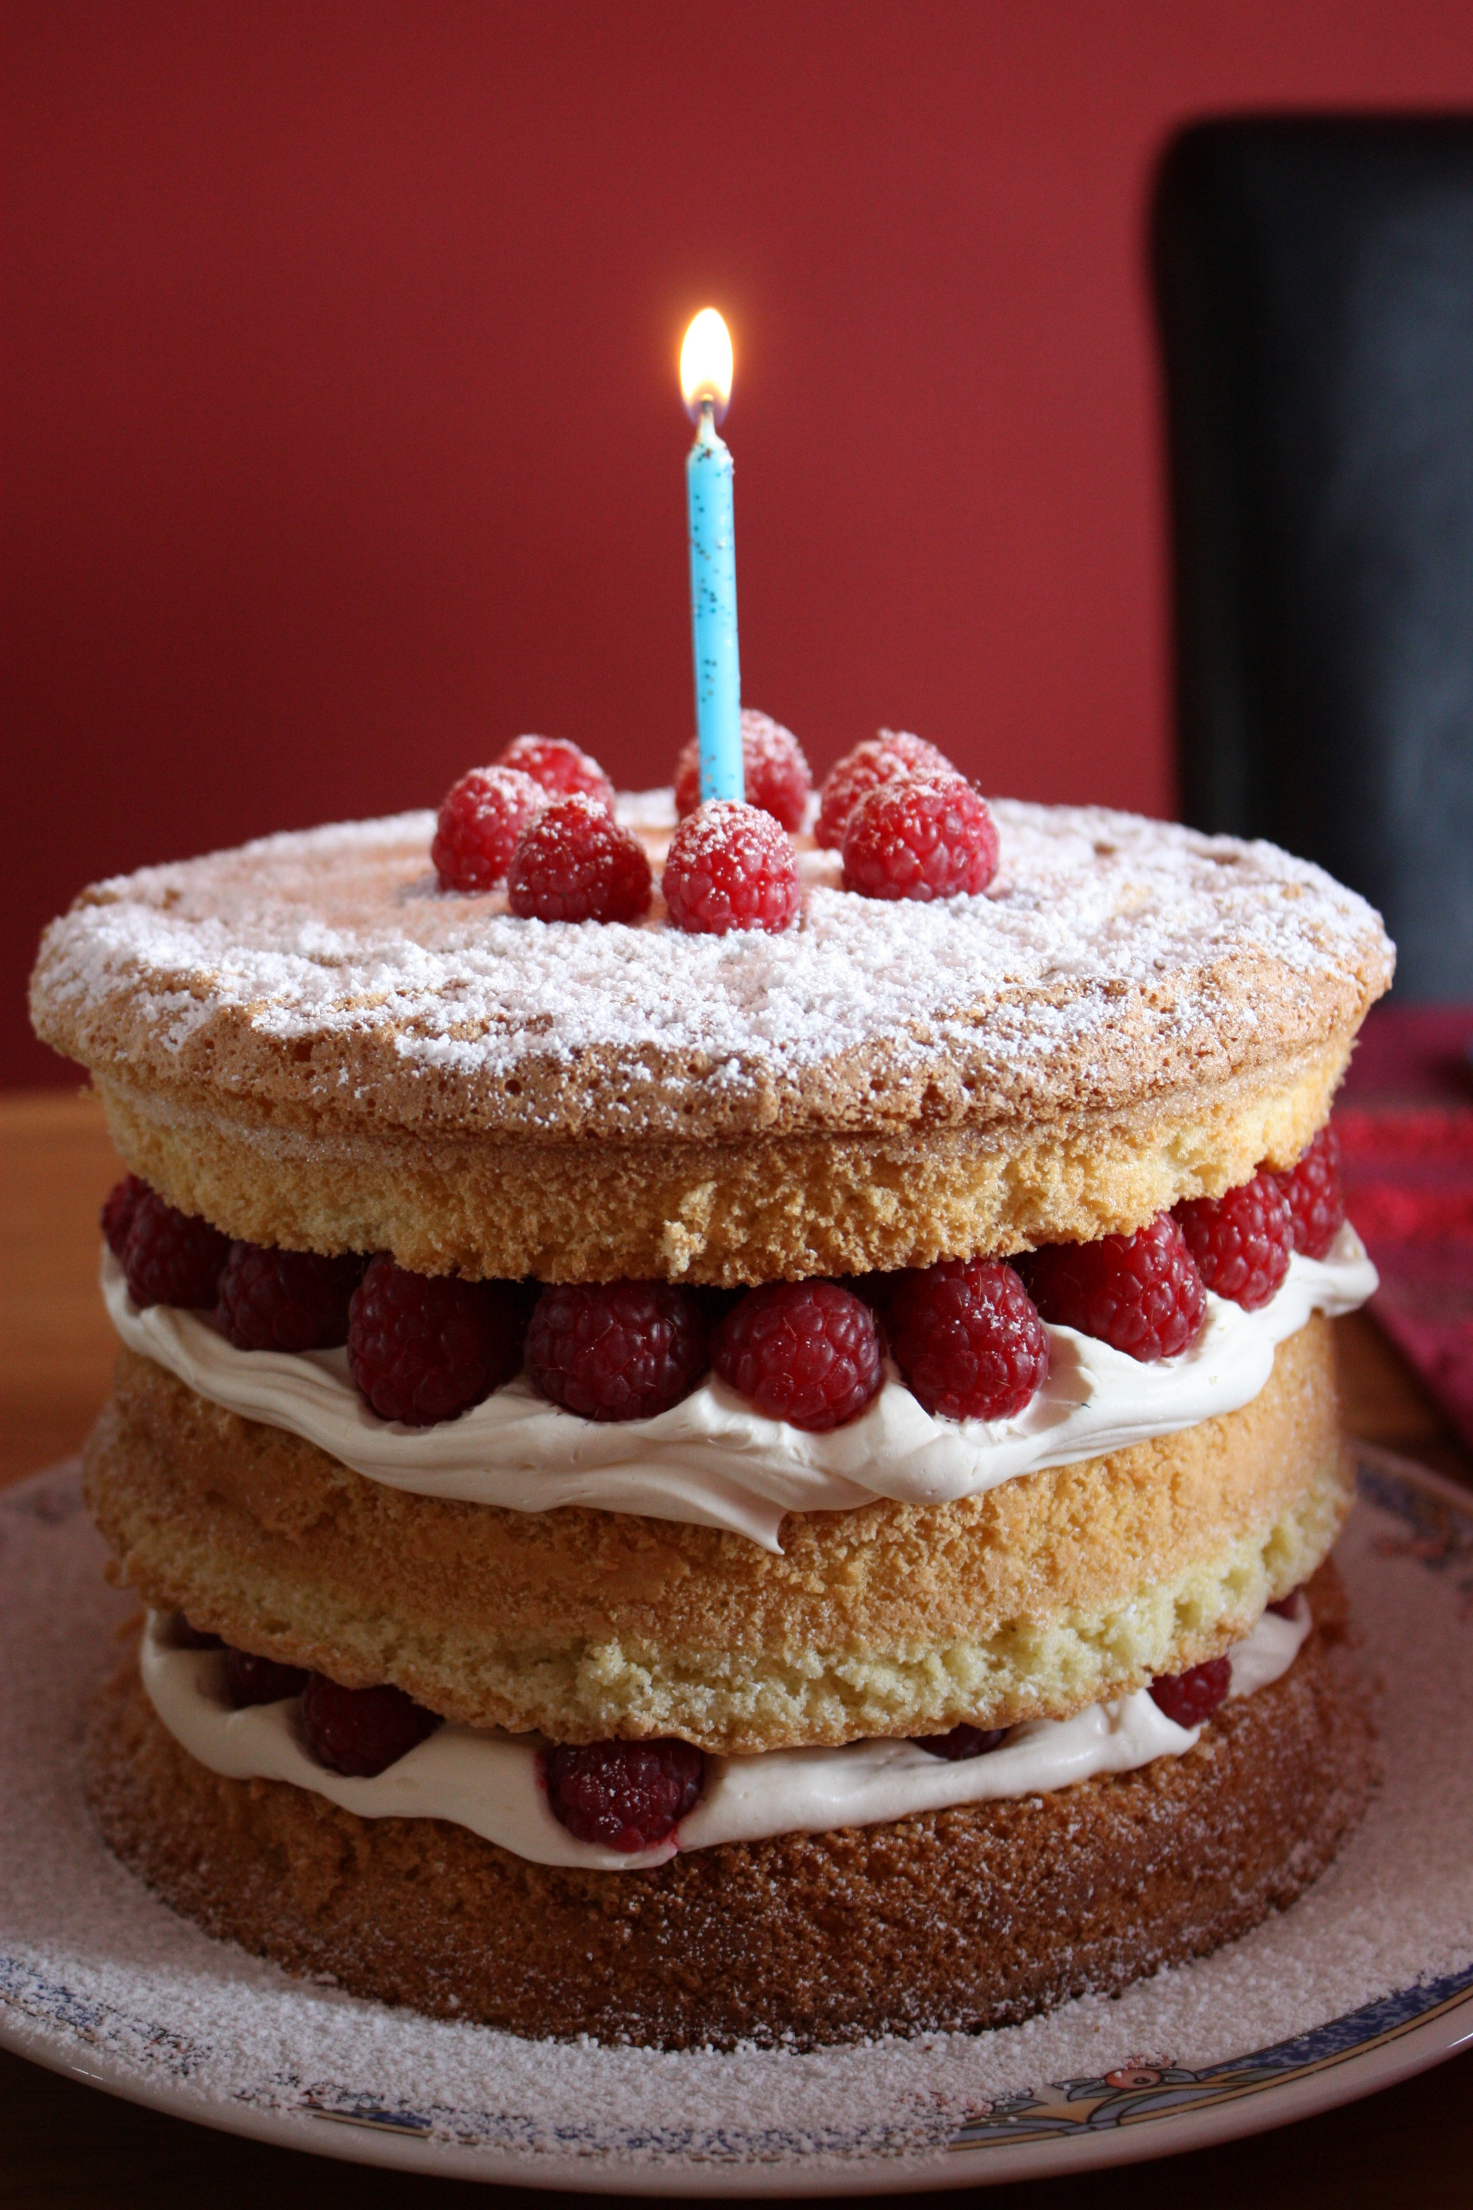
j

